Optimization of group AC/DC hybrid offshore electrical system for offshore wind farms
Appendix
Appendix Table I Performance of different models in terms of prediction
OWF | Capacity [MW] | Number of WTs | Offshore distance[km]
OWF1 | 210 | 42 | 71.4
OWF2 | 200 | 40 | 63.6
OWF3 | 180 | 36 | 65.3
OWF4 | 240 | 48 | 79.5
OWF5 | 200 | 40 | 80.9
OWF6 | 180 | 36 | 87.8
OWF7 | 280 | 56 | 100
OWF8 | 320 | 64 | 107.9
OWF9 | 280 | 56 | 101.5
OWF10 | 270 | 54 | 107
OWF11 | 210 | 42 | 70
OWF12 | 320 | 64 | 123.8
OWF13 | 280 | 56 | 127
OWF14 | 320 | 64 | 81.5
OWF15 | 280 | 56 | 87.5
OWF16 | 320 | 64 | 105

Appendix Table II Electrical parameters of some common cables in AC
Voltage  (kV) | Cross-section(mm²) | Conductor resistance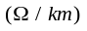 | Capacitance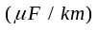 | Steady state current(A) | Cable cost per set(k$/km)
35 | 50 | 0.378 | 0.4018 | 175 | 150
35 | 70 | 0.268 | 0.3865 | 215 | 169
35 | 95 | 0.193 | 0.3735 | 255 | 187
35 | 120 | 0.153 | 0.3637 | 300 | 208
35 | 150 | 0.124 | 0.354 | 335 | 229
35 | 185 | 0.0991 | 0.3456 | 375 | 258
35 | 240 | 0.0754 | 0.3365 | 430 | 272
35 | 300 | 0.0601 | 0.328 | 480 | 284
35 | 400 | 0.047 | 0.3256 | 550 | 353
220 | 400 | 0.0613 | 0.12 | 615 | 673
220 | 500 | 0.0484 | 0.136 | 732 | 884
220 | 630 | 0.0384 | 0.151 | 808 | 980
220 | 800 | 0.0288 | 0.163 | 879 | 1047
220 | 1000 | 0.0232 | 0.177 | 942 | 1210

Appendix Table III Electrical parameters of some common VSC-HVDC cables
Voltage（kV） | Cross-section(mm²) | Conductor resistance | Steady state current(A) | Cable cost per set(k$/km)
±320 | 1000 | 0.0224 | 1644 | 958
±320 | 1200 | 0.0192 | 1791 | 1053
±320 | 1400 | 0.0165 | 1962 | 1137
±320 | 1600 | 0.0144 | 2123 | 1220
±320 | 2000 | 0.0115 | 2407 | 1316

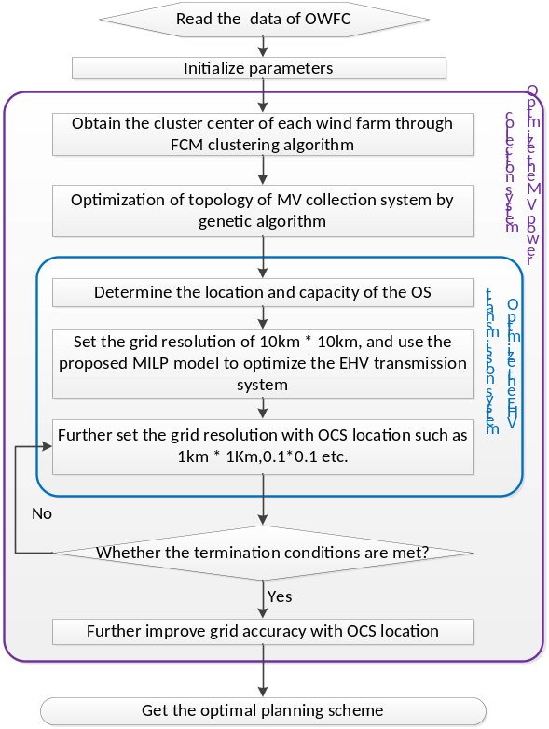
Fig. A1. Flowchart of the topological optimization for OWFC

